1.
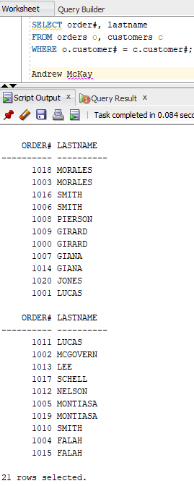
This Query uses the Customer number shared by the orders and customers tables to connect them. The query outputs the Order from the order table number and the last name of the customer taken from the customer table.

2.
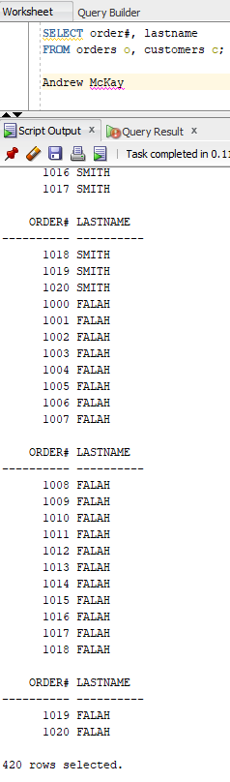
It returns a massive number of results, this is because the rows are multiplied together without the WHERE clause

3.
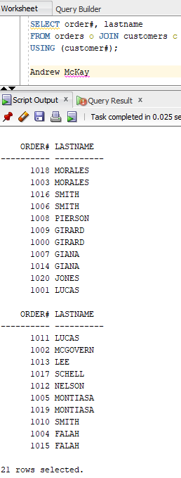

4.
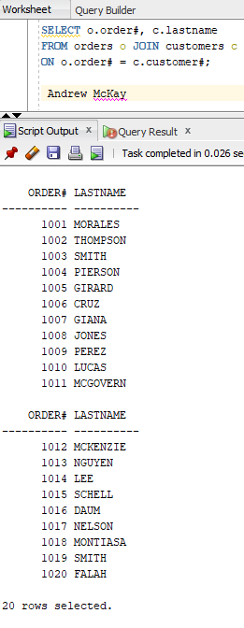

5.
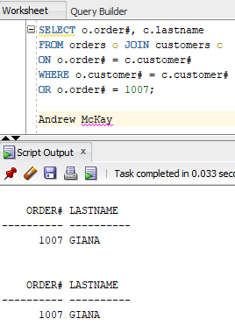
I have retrieved the last name of the customer who placed order 1007 by joining row order number on the customer number, as well as joining the customer number in both tables or where the order number is 1007

6.
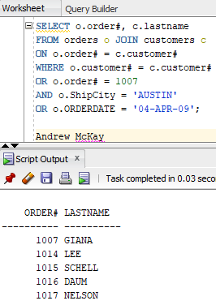
I retrieved the last name of the customer and the order number from the customers and orders tables respectively joining them using ON o.order# = c.customer# given these fields are not equal the results shown are where the order# is 1007 AND the order was shipped to Austin OR the date the order was placed was April 4th 2009

7.
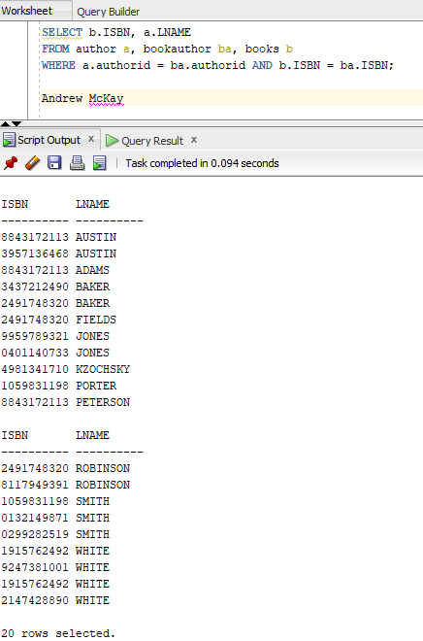
This query shows all the ISBNs of the book and all the last names of the authors. I joined the author table with the bookauthor table and joined THAT with the books table. In the where coulumn I joined the authorid column the author and book author tables share and the ISBN coulmun the bookauthor and books table share.

8.
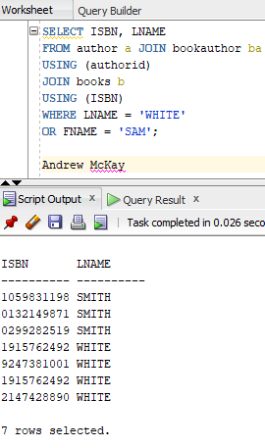
This query shows all the ISBNs of the book and all the last names of the authors. I joined the author table with the bookauthor table and joined THAT with the books table. Using the USING keyword the authorid column the author and book author tables share and the ISBN column the bookauthor and books table share. IT only shows the results where the author’s last name is White or the author’s first name is Sam

9.
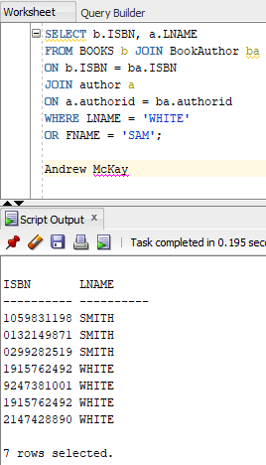

This query shows all the ISBNs of the book and all the last names of the authors. I joined the author table with the bookauthor table and joined THAT with the books table. Using the ON keyword I connected the ISBNs in the books and bookauthors tables and the authored in the author and bookauthor tables. IT only shows the results where the author’s last name is White or the author’s first name is Sam.

10.
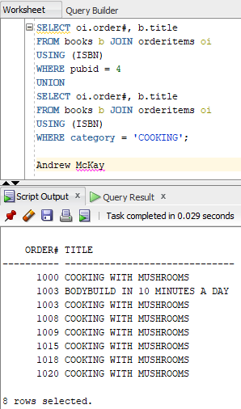
This Query is two queries together, It selects all the order# or the order table, and the titles of the books in the books table USING the ISBN column that the tables share ONLY showing the results that have 4 for the publisher ID. The union Key word removes copies in the query.

11.
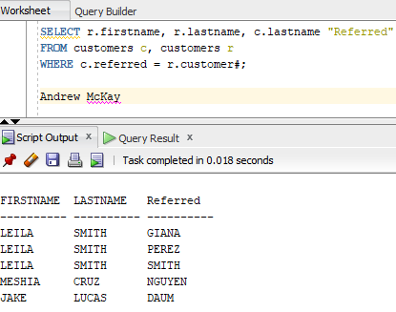
The Query self joins the customers table to show the First and Last name of the customer and the last name of the customer that referred to them. It joins the customers table to itself by having the referred column under a different alias than the normal first and last name and links that to the customer number back in the other table alias.
Andrew McKay
IT-314-002 (Fall 2023)

